University of the People

CS3305 Web Programming 2

Unit 7 Written Assignment 7

Anonymous Student

In this assignment, you will download and deploy a Joomla module to your Joomla site.

**Joomla module**

1. Visit the following Joomla extensions site: [**https://extensions.joomla.org/**](https://extensions.joomla.org/).

2. Browse the catalog of extensions and select the one you would like to add to your Joomla website

3. Download the extension you would like to use for your Joomla website (choose a FREE extension, you do not have to pay for any extension).

4. After you have downloaded the extension, log into the administrator’s panel of your Joomla website.

5. Click Extensions.

6. Click Install.

7. Scroll down and upload the extension you downloaded previously.

8. Configure the extension if you are asked to.

9. Once the extension is installed, visit your Joomla website.

10. Take a screenshot of the new module that you have installed on your website.

11. Copy and paste the screenshot into a word processing document. Save the document as *Joomlaextension*.

12. Upload the document to the assignments section.

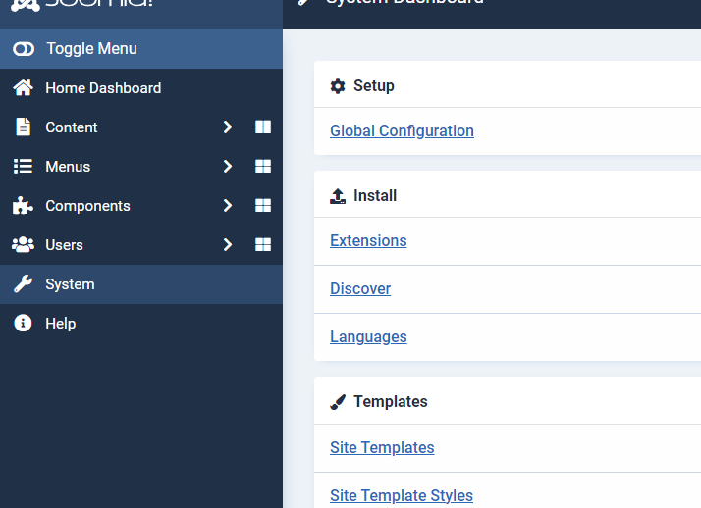 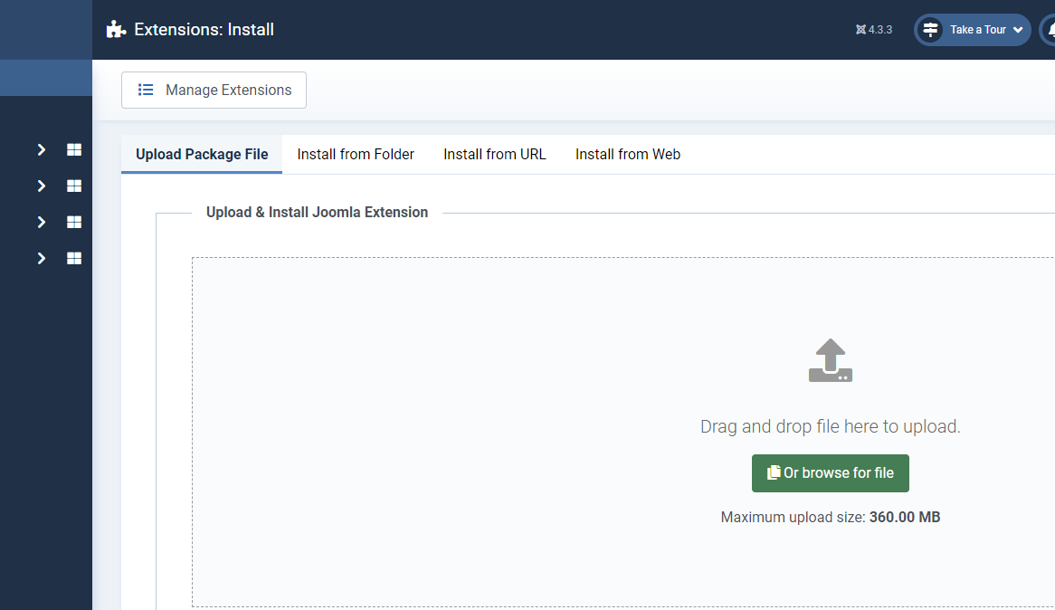

Download and install the component of Convert Form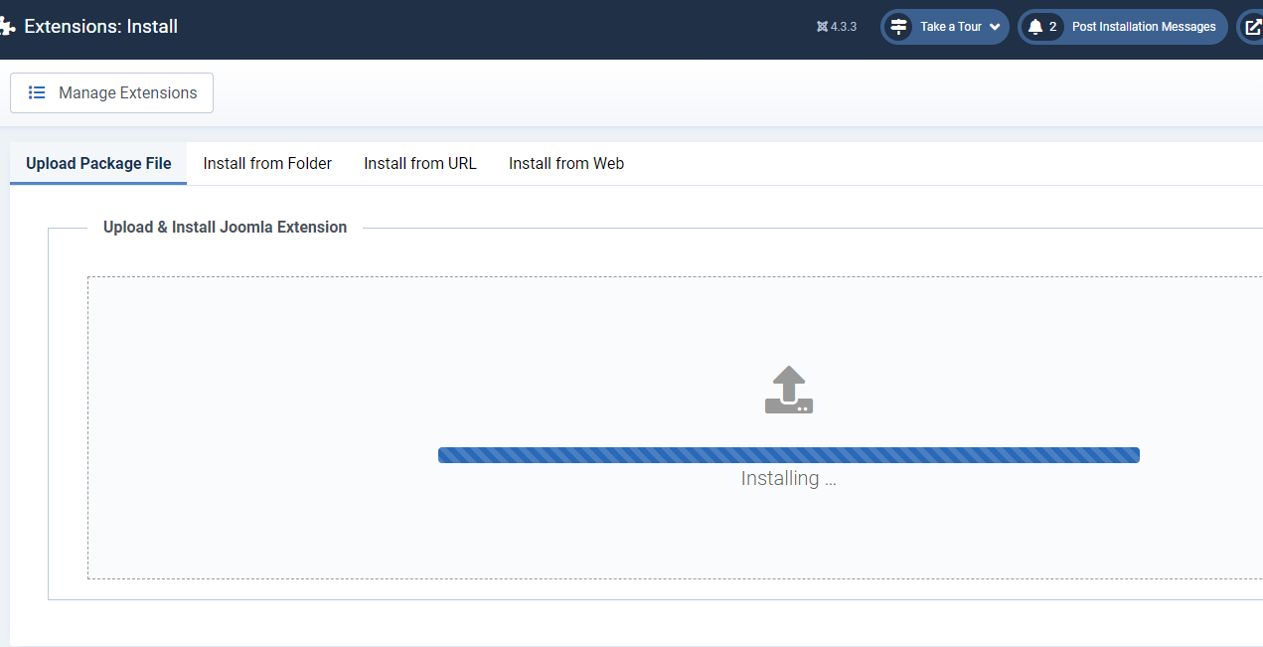

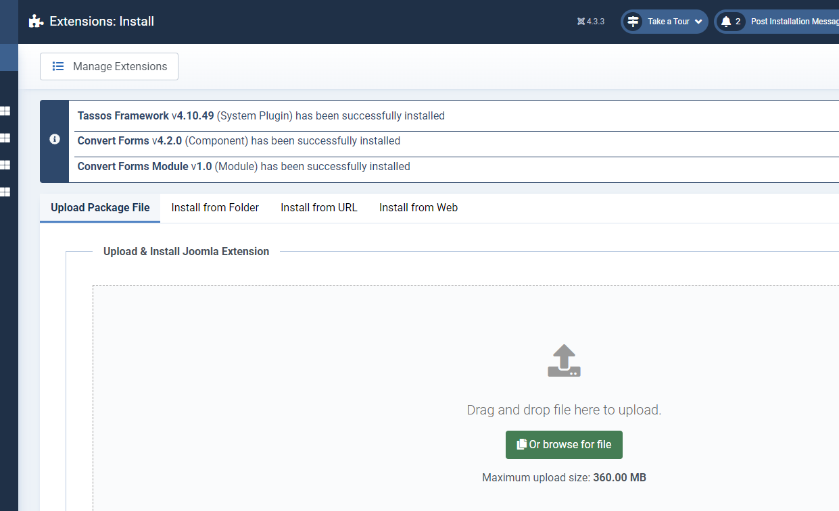



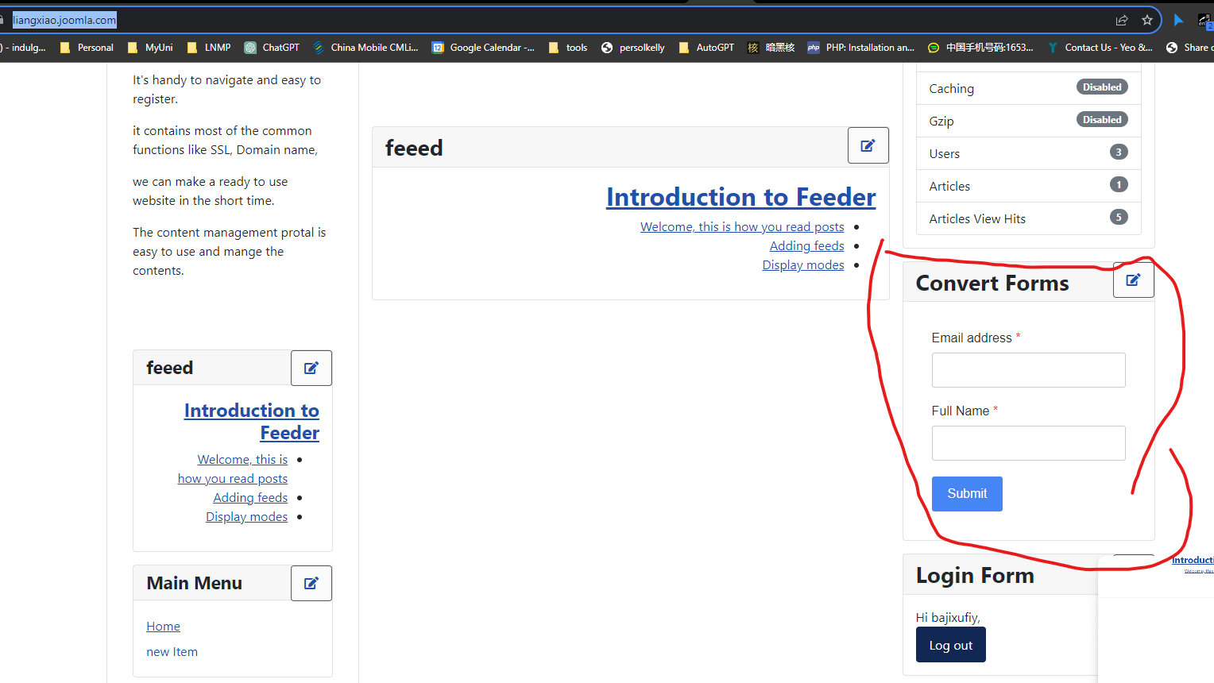

The convert form module and component is installed successful.

The page is available at https://liangxiao.joomla.com/